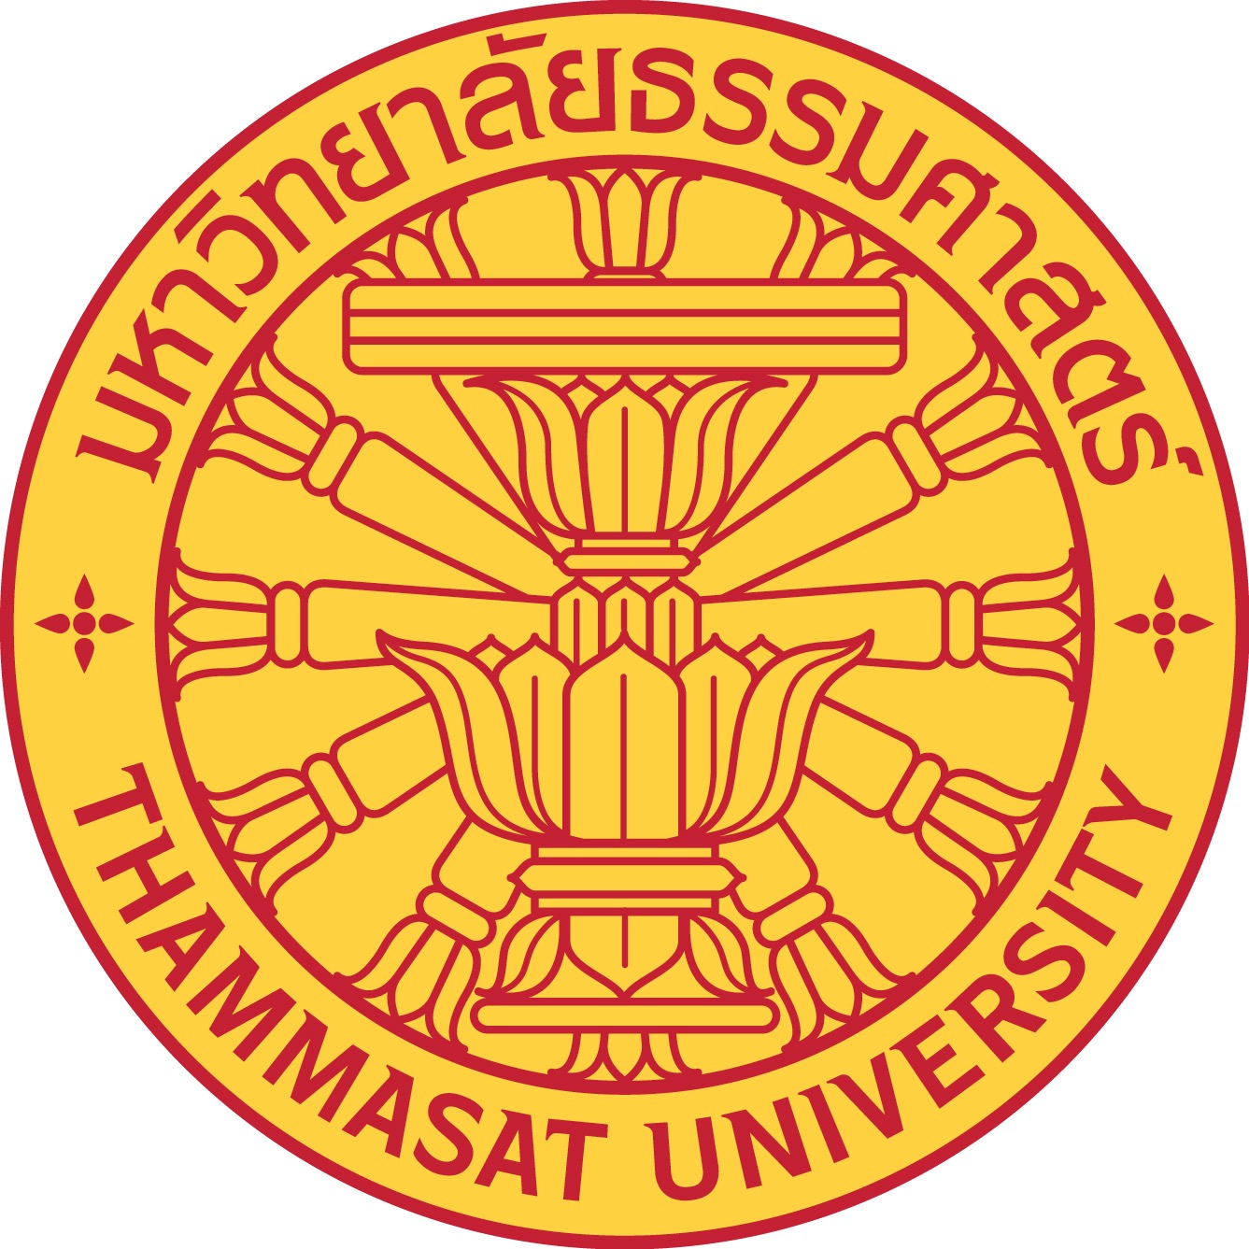

Bualuang ASEAN Fellowship
Application Form

Please read the Program information before completing the form.

1. Applicant's personal details
Title
Family name
First name(s)/Given name(s)
Date of birth
Gender
Nationality

2. Institution at which the Applicant is currently working
University/Institution
Department/Institute
Street, P.O. Box
City/Town
Country
Phone number
Email address

3. Awards and honours
Year | Name of the award/honour

4. Keywords (up to five) to define the applicant's special field of research
Keyword 1
Keyword 2
Keyword 3
Keyword 4
Keyword 5

5. Brief description of the applicant's outstanding academic achievements to date
(2,000 characters max)

6. Please state the period for which the applicant has already been invited to collaborate with specialist colleagues at Thammasat University.
The project duration of about six to twelve months may be divided into segments within two years. The period does not need to be continuous.
Planned duration | Planned locations

7. Name and address of host at Thammasat University
Title
Family name
First name(s)/Given name(s)
University/Institution
Department/Institute
Street, P.O. Box
City/Town
Country
Phone number
Email address
Date of Nomination

8. Required documents
The application has to be submitted via email to the Bualuang ASEAN Fellowship Program (ssiriwan@tu.ac.th). The following documents have to be attached:

1. Completed application form
2. Cover letter to the Rector of Thammasat University
3. Invitation letter from the host institute for the applicant’s research visit indicating activities and time duration
4. Project proposal describing the planned research project containing a detailed work schedule (not more than ten pages including references)
5. List of the applicant's publications in the past ten years

